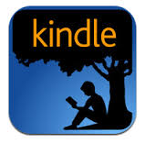
Kindle Devices and Kindle App
- Do to: washk12lib.overdirve.com
- Login using your school email address and email password.
- Browse/search for a Kindle book to borrow in the collection.
- Select the title you wish to read.
- You will be taken to your reading bookshelf.
- From your bookshelf, select
Download>Kindle Book>Confirm & Download
- You will be directed to Amazon.com where you can sign into your Amazon account associated with your device and select Get Library Book where the book will be delivered to your device or app.
- Your book will stay checked out to you and remain on your device until the due date. To return sooner, login to your amazon account associated with your kindle device, select Manage Content & Device. Check box next to title to return. Click the ……..icon and select Return Title.

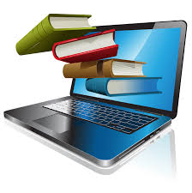
Download or Web Brower
- Go to: washk12lib.overdrive.com
- Login using your school email address and email password
- Browse/search for a Kindle book to borrow in the collection
- Select the title you wish to read.
- You will be taken to your reading bookshelf.
- From your bookshelf, select Download or Read in your Browser. Selecting Read in your Browser will immediately open the book for reading (as long as you are on wireless connection). Download will add the title to your device.
- Your book will stay checked out to you and remain in your bookshelf until the due date. To return sooner login to washk12.lib.overdrive.com, go to your bookshelf, click Return Title

